**Sprint 1 Plan**

**UCSC Academic Planner, April 25th 2023**

**Goal**

* Get basic frontend working, showing a planner that users can fill out that provides support for a few majors to tell whether they have requirements to declare/graduate.

**User Story**

* 1.1 As a UCSC student I want to be able to create a 4 year academic plan so that I will be able to plan ahead [3]
  + Create basic front end
* 1.2 As a student I want to be able to have an option for generating my plan using a friendly web application.
* 1.3 As an ECE Major I want access the department website through a options/button so that I can get extra information on my major [3]
  + Create department button
* 1.4 As a CS student I want to be able to see the courses I need to take [3]
  + Manually add classes for CS
* 1.5 As a UCSC student I want to see if I can declare my major with the classes I have taken [3]

**Team Roles**

Betros Abraha (Product Owner)

Jin Lee (Scrum Master)

Brandan Fong

Sean Carlyle

Michelle Hernandez

**Task Assignment**

Betros Abraha: User story 1.2

Jin Lee: User story 1.3

Brandan Fong: User story 1.4

Sean Carlyle: User story 1.5

Michelle Hernandez: User story 1.1

**Initial Burnup Chart**

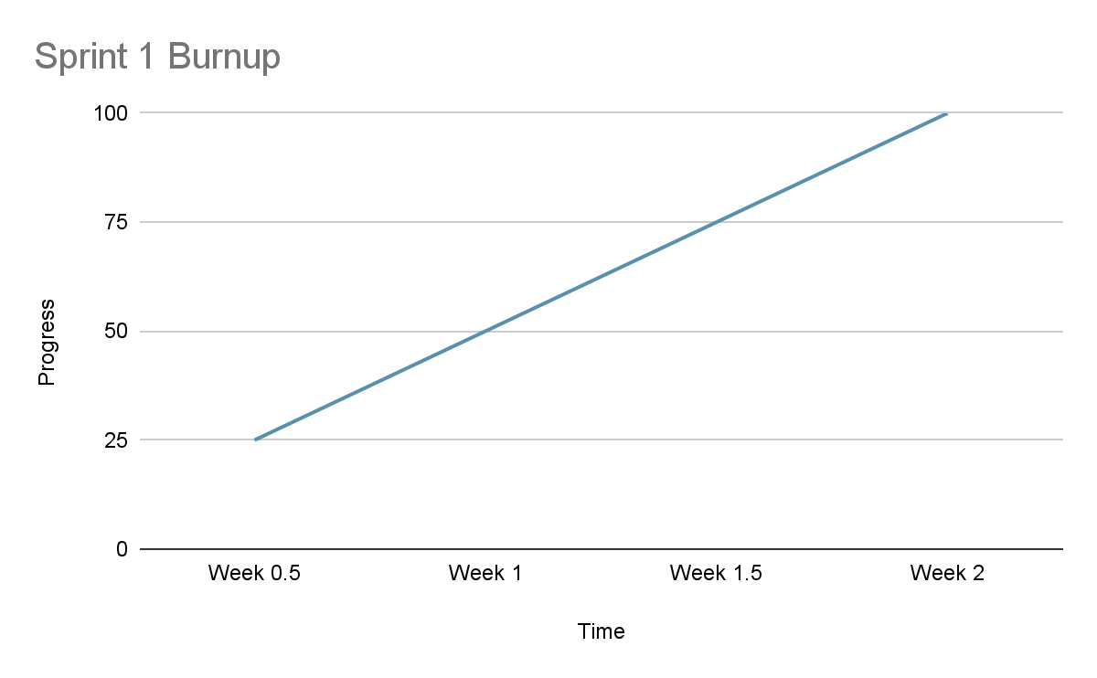

**Initial Scrum Board**

| **User stories** | **Tasks not started** | **Tasks in progress** | **Tasks completed** |
| --- | --- | --- | --- |
| 1 | 5 | 5 | 0 |

**Scrum Times**

Meeting MF 9:05am

TA meeting: W 4:45pm

**Sprint Plan Template - CMPS 115 – Software Methodology**

At the end of your team's sprint planning meeting, the team needs to turn in a sprint plan. This document needs to be typewritten (or the team needs to use a web-based agile planning tool and provide the TA/tutor access to the tool to view the project) and have the following elements:

∙ **Heading:** Document name ("Sprint {number} Plan"), product name, team name, sprint completion date, revision number & revision date.

∙ **Goal:** Short, 1-2 sentence description of the high-level goal(s) for the sprint. ∙ **Task listing, organized by user story:** This section lists the user stories, in priority order from most important (top) to least important (bottom). Within each user story, there needs to be a list of tasks required to implement the user story, along with the time estimate for each tasks (preferably less than or equal to 6 ideal hours). This should look like:

*User story 1 ("As a {user role}, I want {goal} [so that {reason}]")*

*Task 1 description (time estimate for task 1)*

*Task 2 description (time estimate for task 2)*

*...*

*Task N description (time estimate for task N of user story 1)*

*Total for user story 1: XX hours*

*User story 2*

*Task 1 description (time estimate for task 1)*

*Task 2 description (time estimate for task 2)*

*...*

*Task N description (time estimate for task N of user story 2)*

*Total for user story 2: YY hours*

*...*

*User story M*

*Task 1 description (time estimate for task 1)*

*Task 2 description (time estimate for task 2)*

*...*

*Task N description (time estimate for task N of user story M)*

*Total for user story M: ZZ hours*

∙ **Team roles:** Give a listing of all team members. Next to the team member, list their role(s) for this sprint. Assign each person to at least one role (for example, this role might be "Developer"). This looks like:

*Team member 1: role 1 {, role 2, role 3}*

*Team member 2: role 1 {, role 2, role 3}*

*...*

*Team member N: role 1 {, role 2, role 3}*

∙ **Initial task assignment:** A listing of each team member, with their first user story and task assignment. This should look like:

*Team member 1: user story, initial task*

*Team member 2: user story, initial task*

*...*

*Team member N: user story, initial task*

∙ **Initial burnup chart:** A graph giving the initial burnup chart for this sprint and is labeled as such with sprint number and project name and is located in the lab.

∙ **Initial scrum board:** Also known as a task board, the scrum board is a physical board and labeled as such with sprint number and project name and located in the lab. This board has four columns, titled user stories, tasks not started, tasks in progress, and tasks completed. Index cards or post-it notes representing the user stories and the tasks for this sprint should be placed in the user stories, tasks not started, and tasks in progress columns. Tasks associated with a user story should be placed in the same row as the user story.

∙ **Scrum times:** List at least the three days and times during the week when your team will meet and conduct Scrum meetings. Also, indicate which of these meetings will have the TA/tutor visit as arranged with the TA/tutor. It is expected the TA/tutor will visit during the Scrum meeting during your lab time.

Note that if the team ended up modifying its release plan during sprint planning, submit an updated release plan document also with the sprint plan.

Last modified: 10/15/13 adapted from materials for cmps171